PROGRAM |  | APPEARANCE | RULES
SNAP | Initial SNAP EBT Transaction | 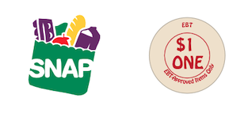 | —Eligible for any food item excluding alcohol and hot and/or prepared foods  —Do not expire
SNAP - KDD | SNAP Fruits & Veggies | 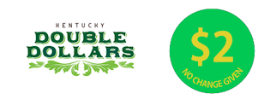 | —Eligible only for Kentucky-grown vegetables, fruits, herbs, and edible plant starts  —Do not expire
SNAP - KDD | SNAP Meat, Eggs, & Dairy | 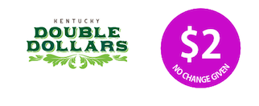 | —Eligible only for Kentucky-raised meat, eggs, and dairy  —Do not expire
SENIOR FARMERS MARKET NUTRITION PROGRAM - KDD |  | 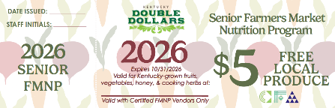 | —Eligible only for Kentucky-grown fruits, vegetables, honey, and cooking herbs  —Do not accept expired vouchers or vouchers from other markets  —Expires 10/31 of each year
WIC FARMERS MARKET NUTRITION PROGRAM - KDD |  | 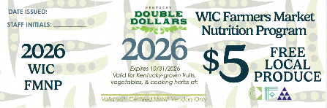 | —Eligible only for Kentucky-grown fruits, vegetables, and cooking herbs  —Do not accept expired vouchers or vouchers from other markets  —Expires 10/31 of each year
